**Oracle 32 bit Client**

1. Click on this link :

<https://www.oracle.com/database/technologies/oracle12c-windows-downloads.html>

1. Download the client software based on your requirement

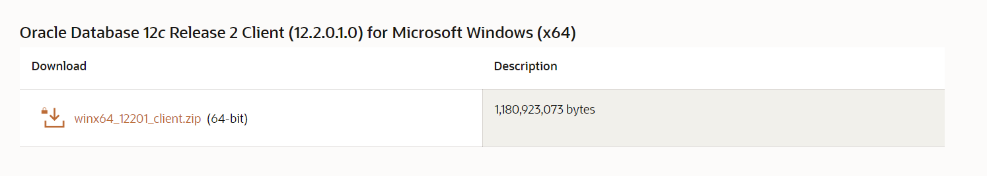

1. Extract the downloaded file
2. Right click on setup and run as administration

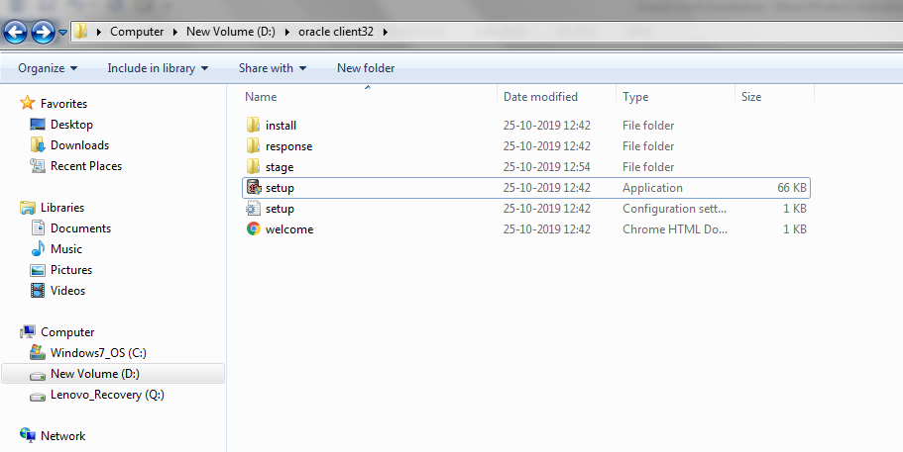

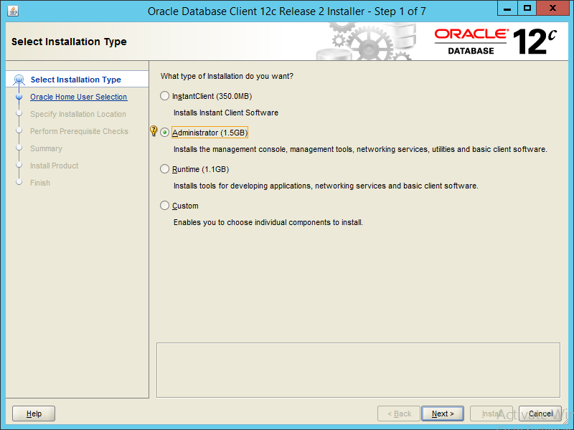

Choose Administrator and click on Next

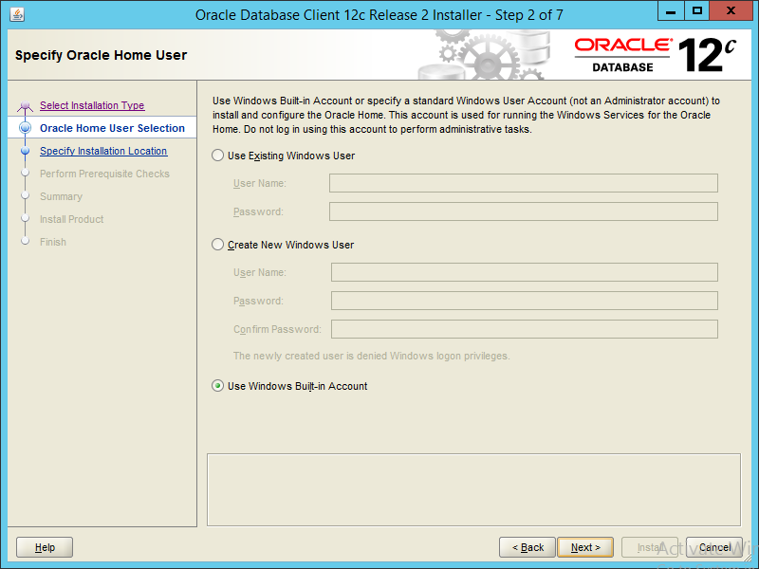

Choose “use windows Built-in Account” and click on Next

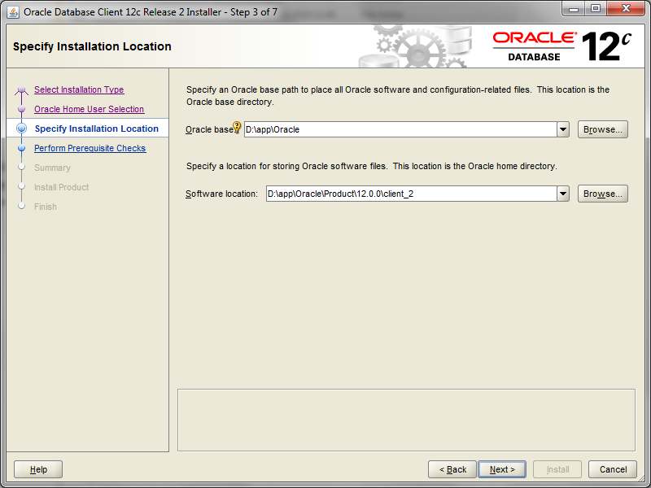

Input the location where you want to install the database

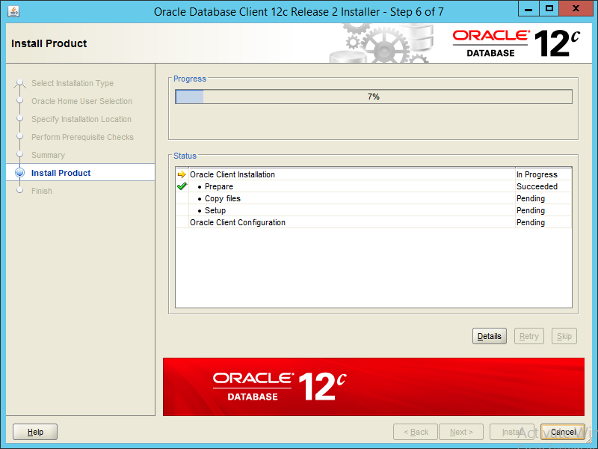

Wait until the installation completes

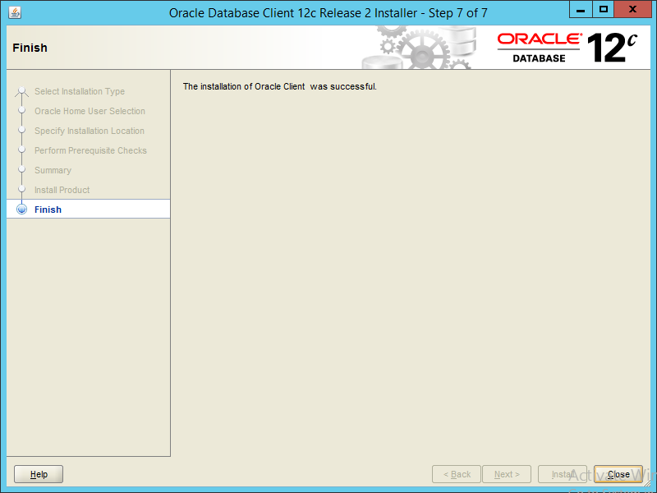

Installation is successful, click on close.

**Post installation Task of Oracle Client:**

PATH SETTING:

ORACLE_HOME= C:\ORACLE_12C_CLIENT\product\12.2.0\client_1

Path= C:\ORACLE_12C_CLIENT\product\12.2.0\client_1\bin

